ADRIAN TURION |  | Avenue de Sainte-Clotilde 9  1205 Geneva, Switzerland | 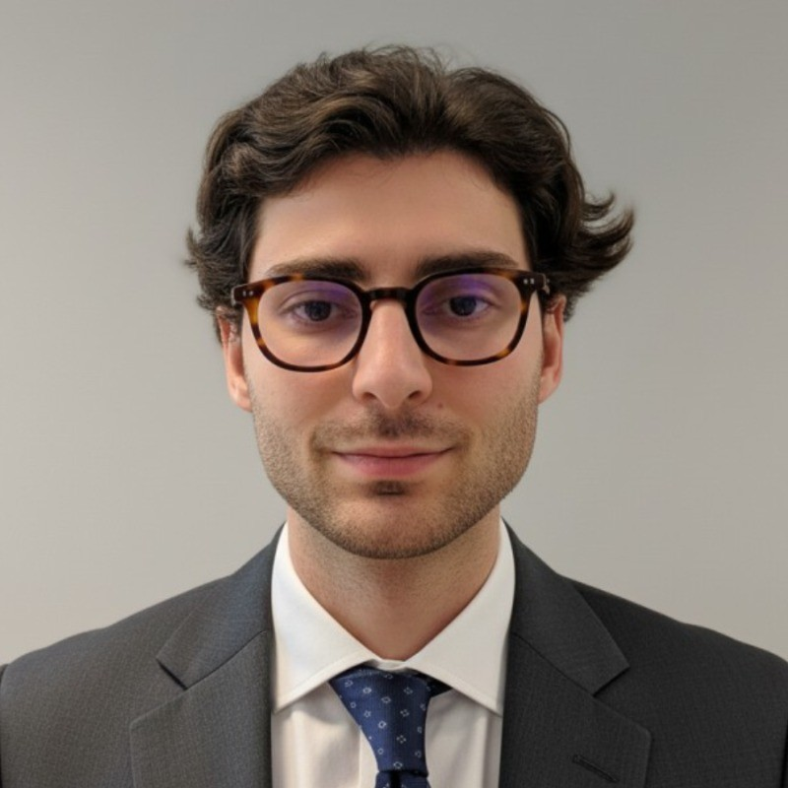
turionadrian@gmail.com | Swiss | 10.11.2000 |  | +41 77 262 37 96
INTRODUCTION
Transaction-focused MSc Finance candidate with debt advisory and structuring experience across 7+ mandates up to CHF 50M. Autonomous and entrepreneurial profile developed in a lean deal team, combining rigorous financial modeling with hands-on due diligence coordination. Strong fit for high-growth environments requiring independent execution and analytical rigor.
WORK EXPERIENCE
Auraïa Capital Advisory – Small & Mid Cap Cross-border M&A Boutique  Mergers & Acquisitions Analyst (Converted internship into full-time position) |  | Geneva, Switzerland  Aug 2024 – Current
- Staffed on 7 live mandates including debt advisory across healthcare, tech, and life sciences sectors with deal values EUR 5M-50M, managing full transaction lifecycle from origination through closing and post-deal monitoring
- Built detailed financial models (LBO, DCF, trading comps, precedent transactions) and conducted quality of earnings analysis to assess investment risks and key value drivers for client and Board presentations
- Coordinated with legal, tax, and accounting advisors to structure transactions, supervising comprehensive due diligence processes (juridique, technique, financiere) across multiple concurrent mandates

RC Group – Currently under LBO with Crédit Mutuel Equity  Mergers & Acquisitions Intern |  | Paris, France  Feb 2024 – Aug 2024
- Conducted financial and operational due diligence on 3 acquisition targets with revenues EUR 10M-30M, preparing investment memos with market analysis, competitive positioning, financial projections, and synergy assessments for investment committee

Europ Assistance – Subsidiary of Generali Insurance  Financial Analyst Intern |  | Geneva, Switzerland  Apr 2023 – Aug 2023
- Built automated financial dashboards in Excel and PowerBI to track KPIs for CHF 50M+ revenue subsidiary, performed variance analysis on monthly P&L, supported quarterly forecasting for 5 business units, and developed cost allocation and profitability models

LEADERSHIP
- McKinsey Case Finalist: Developed data-driven model to forecast market events using statistical analysis, presenting to executives with potential CHF 200K annual revenue impact
- Screeny.ai Founder: Built AI software for investment banks to identify acquirers, reducing buyer search time from 10+ hours to 20 minutes, adopted by 3 advisory firms
- Portfolio Manager: Manages diversified investment portfolio using options strategies, generating 8% annualized returns through disciplined risk management
EDUCATION
HEC Lausanne  Master of Science in Finance |  | Lausanne, Switzerland  2021 – 2024
- Cumulative GPA: 5.2/6.0 (Top 15% of the class cohort)
- Exchange programs at Waseda University (Tokyo, Japan) and Maastricht University (Maastricht, Netherlands)
- Relevant Coursework: Fixed Income and Credit Risk, Valuation, Corporate Finance, Risk Management
- Thesis Topic: Synergies Analysis of the Merger between American Airlines & US Airways

Bachelor of Science in Management |  | 2018 – 2021
- Cumulative GPA: 4.7/6.0

Scientific Baccalaureate with Highest Honors (16.6/20) |  | Aix-en-Provence, France
ADDITIONAL INFORMATION
Languages:  Computer:  Interests:  References: | French (Native, C2), Spanish (Native, C2), English (Fluent, C1), German (Business proficient, B2-C1)  Financial Modeling | Risk Analysis | Due Diligence | Excel | French/English/German  Geopolitics, Badminton (Provence regional finalist), Gym, Real use cases of Artificial Intelligence  Guillaume Arnaldez – Ex-Director at Auraïa Capital Advisory, guillaume.arnaldez@auraia.ch  Sacha Caravatti – CFO at Europ Assistance Switzerland, scaravatti@europ-assistance.ch

